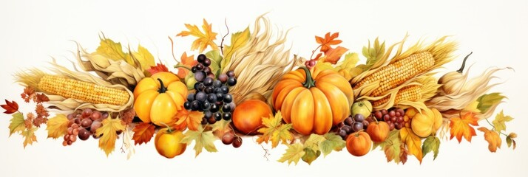

Welcome to Immanuel Lutheran Church
630 Adams St Wausau, WI 54403 | ​​Phone: (715) 842-3644
http://www.immanuelwausau.org/
Sunday, November 19, 2023,
25th Sunday after Pentecost

Please welcome Pastor Gary Froseth to Immanuel as he leads us in Worship and celebrates Holy Communion with us today.

Prelude
Announcements
Introduction
Our readings during November speak of the end times. Zephaniah proclaims that the coming day of the Lord will be filled with wrath and distress. Paul says it will come like a thief in the night and urges us to be awake and sober. Jesus tells the parable of the talents, calling us to use our gifts, while we still have time, for the greater and common good. In a world filled with violence and despair, we gather around signs of hope—word, water, bread, and wine—eager to welcome the good news of Christ’s coming among us.

Please stand if able.
Confession and Forgiveness
Blessed be the holy Trinity, ☩ one God,
in whose image we are made,
who claims us and calls us beloved.
Amen.

Silence is kept for reflection.

Holy One,
we confess that we are not awake for you.
We are not faithful in using your gifts.
We forget the least of our siblings.
We do not see your beautiful image in one another.
We are infected by sin
that divides your beloved community.
Open our hearts to your coming,
open our eyes to see you in our neighbor,
open our hands to serve your creation.
Amen.
Beloved, we are God’s children,
and Jesus, our Beloved, opens the door to us.
Through ☩ Jesus you are forgiven,
by Jesus you are welcome,
in Jesus you are called to rejoice!
Let us live in the promises prepared for us
from the foundation of the world.
Amen.

Opening Hymn “As We Gather At Your Table” # 522

Greetings: “The grace of the Lord Jesus Christ and the love of God and the communion of the Holy Spirit be with you all” ( 2 Corinthians 13:14).
C: And also, with you.

Prayer of the Day

P: Righteous God, our merciful master, you own the earth and all its peoples, and you give us all that we have. Inspire us to serve you with justice and wisdom, and prepare us for the joy of the day of your coming, through Jesus Christ, our Savior and Lord.

Amen.

Please be seated.
First Reading: Zephaniah 1:7, 12-18
R: A reading from Zephaniah

R: Word of God, Word of life
C: Thanks be to God.

Psalm 90:1-8 [9-11] 12
R: Let us read responsively.
¹Lord, you have | been our refuge
from one generation | to another.
²Before the mountains were brought forth, or the land and the | earth were born,
from age to age | you are God.
³You turn us back to the | dust and say,
“Turn back, O child- | ren of earth.”
⁴For a thousand years in your sight are like yesterday when | it is past
and like a watch | in the night; R
⁵you sweep them away | like a dream,
they fade away suddenly | like the grass:
⁶in the morning it is | green and flourishes;
in the evening it is dried | up and withered.
⁷For we are consumed | by your anger;
we are afraid because | of your wrath.
⁸Our iniquities you have | set before you,
and our secret sins in the light | of your countenance.
[ ⁹When you are angry, all our | days are gone;
we bring our years to an end | like a sigh.
¹⁰The span of our life is seventy years, perhaps in strength | even eighty;
yet the sum of them is but labor and sorrow, for they pass away quickly and | we are gone.
¹¹Who regards the power | of your wrath?
Who rightly fears your | indignation?
] ¹²So teach us to num- | ber our days
that we may apply our | hearts to wisdom.

Second Reading: 1 Thessalonians 5:1-11
R: A reading from 1 Thessalonians.

R: Word of God. Word of life.
C: Thanks be to God.

Gospel Acclamation
P: Let us stand for the Gospel
C: Alleluia Lord And Savior pg. 205

Alleluia. They are before the | throne of God,* and the one who is seated on the throne will | shelter them. Alleluia. (Rev. 7:15)
Gospel: Matthew 25:14-30
P: The Holy Gospel according to Matthew.
C: Glory to you, O Lord.
P: The Gospel of the Lord.
C: Praise to you, O Christ.

Please be seated.
Sermon Pastor Gary Froseth

Hymn of the Day “Let Justice Flow Like A Stream” # 717

Please stand if able.
Apostle’s Creed See the yellow sheet in the back of your hymnal.

Please be seated.
Prayers of Intercession
R: United with your saints across time and place, we pray for our shared world. After “Hear us O God”, please respond with “Your mercy is great.”

Sharing of the Peace
P: The peace of Christ with you always.
C: And also, with you.

Offering

Offertory Hymn “In The Singing” # 466

The usher will bring up the offering plate, bread, and wine.

Please stand if able.

Offertory Prayer

P: God of all goodness,

generations have turned to you,

gathered around your table,

and shared your abundant blessings.

Number us among them

that, as we gather these gifts from your abundance,

and give thanks for your rich blessings,

we may feast upon your very self

and care for all that you have made,

through Jesus Christ, our Sovereign and Servant. Amen.
Holy Communion

Great Thanksgiving
P: The Lord be with you. C: And also with you.
P: Lift up your hearts. C: We lift them to the Lord.
P: Let us give thanks to the Lord our God. C: It is right to give our thanks and praise.

Holy, Holy, Holy Lord pg. 207

The Lord’s Prayer
Our Father, who art in heaven,
hallowed be thy name;
thy kingdom come;
thy will be done;
on earth as it is in heaven.
Give us this day our daily bread.
And forgive us our trespasses,
as we forgive those
who trespass against us.
And lead us not into temptation;
but deliver us from evil.
For thine is the Kingdom.
And the power, and the glory,
Forever and ever. Amen

Invitation to Communion
Christ spreads a table before you. Gather here with all the saints.
All are welcome at the Lord’s table. We believe Christ is truly present in the bread and the wine, that is his body and blood are given and shed for you for the forgiveness of sin. If you do not wish to receive communion but wish to receive a blessing, please come forward during the distribution of communion. If you are unable to come forward during distribution and wish to receive communion, please let the usher know and the pastor will come to your seat. Wine and grape juices are available as well as gluten free wafers upon request.

Please be seated.
Lamb Of God pg. 208

Communion Hymn “As The Grains Of Wheat” # 465

Blessing after communion

Prayer after Communion
P: Lord Jesus,
in this simple meal you have set a banquet.
Sustain us on the journey,
strengthen us to care for the least of your beloved children,
and give us glad and generous hearts
as we meet you on the way. Amen.

Please stand if able.
Blessing

Closing Hymn “Praise, My Soul, The God Of Heaven” # 864

Dismissal
P: Beloved of God, go in peace to love and serve the Lord.
C: Thanks be to God.

Postlude

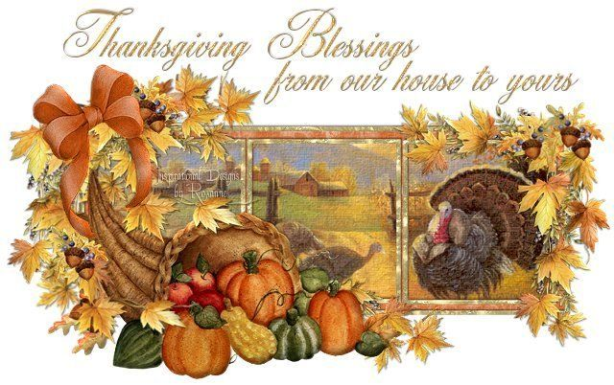

Prayer Concerns: Barb West, Faye Schwarm (Contact ILC office to update.)

In remembrance of Pastor Kenneth Melby: Pastor Melby passed away Friday November 10th, 2023, in Decorah, IA. The family asked that in lieu of flowers donations should be made to First Lutheran Church and Barthell Eastern Star Home. The funeral will be held Saturday, December 02,2023 11:00 am at First Lutheran Church 604 West Broadway Decorah, IA 52101.

November 21, 2023. In the spirit of shared ministry, are three announcements (and one sign up sheet) for events happening at Pilgrim in the months of November and December. Your congregation members, friends, and family members are invited to attend. A Service of Gratitude at 6:30 pm on November 21, the Tuesday prior to Thanksgiving Day. It is preceded by a chili supper and 5:30 pm., A Day of Prayer in the Pilgrim sanctuary on Thursday, November 30th., A Christmas singalong in the Pilgrim sanctuary on Saturday, December 16, at 2:00 pm. It is followed by light refreshments.

November 23, 2023. Thanksgiving Day. There will be no service at Immanuel Lutheran.

November 29, 2023. There will be 4 bible studies for the four weeks of Advent. The first one titled “Revelation” will be held on Wednesday November 29th at 11:30 am in the Fellowship Hall. If you wish you may bring your lunch, and Bob Henning, the study leader, will make coffee as you join him for a lively discussion. The first week’s study guide for the 29th will be on the table in the narthex on Sunday November 26th. This will then continue through the month of December. If you have any questions, please check with Bob. I am looking forward to seeing you there as we prepare for Christmas.
December 03, 2023. 1st Sunday of Advent.

Reminder from your stewardship committee: If you have handed in your Estimate of Giving and Time and Talent card, we want to thank you! If you have not done so yet please hand it in or send it to Immanual Lutheran Church 630 Adams Street, Wausau, WI 54403.

The stewardship committee and church council depend on this information for creating the 2024 budget.

2024 Wall Calendars. Do you have any extra 2024 wall calendars? Please drop them off at the church office for delivery to area nursing homes. You can leave them on the pew by the office. Thank you from the Wausau Golden K Kiwanis.

Bell Choir is starting up again this fall. We would love to have you join us! No “musical talent” needed! Just come join us for friendship and fun. Practice is on Wednesdays at 6:30 pm. For more information call Joanne at 715-573-7379. Just give me a ring!

The Men’s Discussion Group Thursdays at 7:30 a.m. in the Koinonia Room. New participants are most welcome.

Strong Bones Senior Exercise Group meets every Tuesday and Thursday in the old Nursery at 10:30 am. The class is open to anyone wishing to improve balance and maintain strength to prevent falls. New faces are happily welcome.

Volunteers needed to host coffee hour. There is a sign-up sheet in the kitchen.

Attendance on 11/05/23: 32

Our Sister Church is the Lobatla Parish. Address is: c/o Moruti (Pastor) Rev. G.M. Nkale, P.O. Box 160, Motswedi 2870, Republic of South Africa. Email for Pastor: nkalesto@gmail.com

November 2023 Worship Servers
Worship Leader: Pastor Gary Froseth
DATE | PIANIST / ORGANIST | READER | USHER / GREETERS | VIDEO TAPER | COMMUNION
11/19/2023 | Karen Zuidema | Holly Westaby | Dan Westaby | V | Joanne Distelhorst
Altar Guild: Holly Westaby & Kathy Knox

*Next Week 11.12.2023 Worship Service

November 2023 Worship Servers
Worship Leader: Pastor Gary Froseth
DATE | PIANIST / ORGANIST | READER | USHER / GREETERS | VIDEO TAPER | COMMUNION
11/26/2023 | Karen Zuidema | Sue Schwede | Mike Schwede | V | Joanne Distelhorst
Altar Guild: Holly Westaby & Kathy Knox

From sundaysandseasons.com. Copyright © 2023 Augsburg Fortress. All rights reserved. Reprinted by permission under Augsburg Fortress Liturgies Annual License #SAS014524. New Revised Standard Version Bible, Copyright © 1989. Revised Common Lectionary, Copyright © 1992 Consultation on Common Texts, admin Augsburg Fortress. Used by permission.

